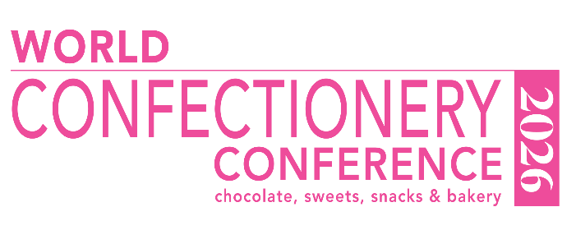

World Confectionery Conference Awards 2026
The awards are free to enter, and companies have until July 7 2026 to nominate their award innovations across our six categories, along with a 350-word maximum description on why their entry is a deserving winner along with a couple of images. This can be done by filling out the below questions and emailing them to Confectionery Production editor Neill Barston at nbarston@bellpublishing.com and also event manager Aimee Carnell at aimee@bellpublishing.com with the subject line: “WCC 26 Award Entry”. If you are entering multiple times, please send separate forms for each entry.
For our finished product category, we will require a sample in order to judge this section as accurately and fairly as possible. Please send samples of the finished product to be judged, please send them to: either Neill Barston or Aimee Carnell at, Bell Publishing Ltd, 57 Bath Street, Gravesend, Kent, UK, DA11 0DF. Please also attach images to use in the judging process for all entries.
2026 Categories:
> Sustainability initiative
> Equipment Innovation
> Team of the Year
> Ingredients Innovation
> Finished Product Innovation
> Emerging enterprise of the year

Entry form:
Company:
Name:
Email:
Telephone:
Category you are entering:
Entry description (up to 350 words):

